GAS CAPITAL SCHOLARSHIP PROGRAM
630 South Main

Hugoton, Kansas 67951

Scholarship Program Policies and Guidelines

Policies

The scholarship program will be administered by a scholarship committee composed of five (5) members. The members of the scholarship committee shall consist of at least one person who is a member of the Board of Directors of the Hugoton Area Chamber of Commerce (or their designee) and the balance of the members of the committee shall consist of citizens who live in one of the following Kansas counties: Morton, Seward, Stevens, Stanton, Grant, Haskell, Hamilton, Kearny, Finney or Greeley. The above mentioned counties may be referred to herein as the Kansas portion of the Hugoton Gas Field. A quorum shall consist of three (3) of the five (5) members.

Applications will be solicited from students who are residents of one of the counties in the Kansas portion of the Hugoton Gas field area who have attended and completed at least two (2) semesters at accredited colleges or universities, including post graduate students, including students in community colleges if such students will continue their schooling at a four year school. High School seniors with at least a 3.3 GPA on a 4.0 scale or comparable scale, will also be considered.

Applications will be screened by the scholarship committee, using the guidelines set out below.

Each year prior to the November meeting of the Scholarship Committee, the Committee shall review the scholarship program, including funding. The Committee shall establish at its November meeting the maximum number of scholarships available for the following school year.

The Gas Capital Scholarship Program is organized not for profit; and the committee shall apply for an exemption from taxation and status as a charitable organization described in the Section 501(c) (3) of the Internal Revenue code of 1954, (or the corresponding provision of any further United States Internal Revenue Code).

The Gas Capital Scholarship Program may administer funds, which are endowed in the name of an individual or company, and the scholarship committee and the donor may work out the details of such scholarship; provided that the members of the Gas Capital Scholarship Program shall administer such specific endowed funds.

Policies and Guidelines - Page 2

Guidelines

The guidelines for the Gas Capital Scholarship Program are as follows:

- It is structured to assure that the goal of the Gas Capital Scholarship Program— promote higher education to students from the Kansas portion of the Hugoton Gas Field—is achieved. The Committee is encouraged to grant scholarship assistance to those students who, based on careful review of qualifications, offer promise to successfully graduate from college.

- It be provided only to students enrolled in, and who have completed at least two (2) semesters at an accredited junior college, college, or university, including post graduate students and have maintained a 2.5 GPA. High School Seniors may also apply and be awarded a scholarship provided they have at least a 3.3 high school GPA on a 4.0 scale or comparable scale.

- It be awarded primarily on the basis of academic excellence as opposed to need. The Committee shall structure this program to recognize academic excellence.

- It contains provision insuring that scholastic records of scholarship recipients are reviewed each school term to determine that the required scholastic standing as deemed necessary is maintained.

- It provides for payment of scholarship funds on a semester or quarterly basis as a means of maintaining ongoing contact with the recipients. The Board recommends that scholarship payments be made at enrollment periods. The Committee shall consider the awarding of certificates to recipients at the time selection is made to recognize the student’s achievements.

- It will be awarded on an annual basis. To continue on scholarship, recipient must reapply each year, completing a new application form including references and providing an up-to-date transcript. (Preferential consideration should be given to a current recipient who has maintained grades).

- A scholarship recipient, who fails to enroll or to maintain grades of scholarship quality, shall be dropped and no further payment made or renewed.

- It is intended to award several scholarships per year in an amount determined by the Committee in its discretion.

Scholarship Applications and Forms

The committee has developed the following forms to be used to assist an applicant in applying for a scholarship:
General Scholarship Requirements
Scholarship Application, and
Appraisal Form,
which exhibits are incorporated as though full set forth herein.

THE GAS CAPITAL SCHOLARSHIP PROGRAM

REQUIREMENTS

- STUDENT ELIGIBILITY:
  - Applications will be solicited from High School Seniors and College Students who are residents of one of the counties in the Kansas portion of the Hugoton Gas Field area (see (1d) below).
  - Scholastic achievement required (on a 4.0 scale - a 3.3 GPA or above for High School Students and a 2.5 average or above for College Students).
  - Must be enrolled as a full time student.
  - Student must be a resident of one of the following Kansas counties: Finney, Grant, Greeley, Hamilton, Haskell, Kearney, Morton, Seward, Stanton and Stevens

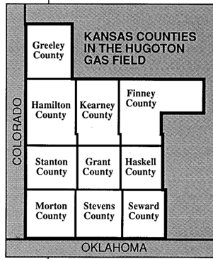
- DEADLINE DATE: Application received on or before February 15.

- APPLICATION REQUIREMENTS:
- Completed Application
- Submit a *Resume which will include: a list of school activities, clubs and honors; leisure time activities, sports and hobbies; work experience; and a brief paragraph indicating your intended major and future plans.
- Submit One (1) *Letter of Reference
- Submit an Up-to-date transcript mailed by high school or college.

- AMOUNT OF SCHOLARSHIP: (determined by Scholarship Committee based on available funds)

- SEND COMPLETED APPLICATION AND REQUIRED DOCUMENTATION TO:

Gas Capital Scholarship Committee
630 South Main
Hugoton, Kansas 67951

(620)544-4305

- METHOD OF SELECTION: Selection will be made by a committee based on scholastic ability and application and appraisal information. Recipients will be notified on or before April/May and will have ten (10) days to accept. If recipient does not accept, the scholarship will be awarded to the alternate selected by the scholarship committee.

SCHOLARSHIP APPLICATION

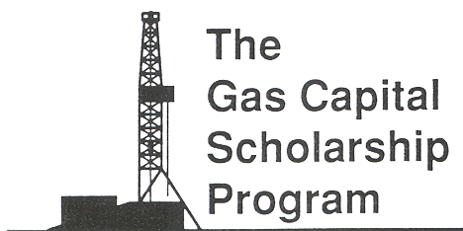GAS CAPITAL SCHOLARSHIP PROGRAM
630 S. Main Hugoton, Kansas 67951
(620)544-4305

Name Date

Address
City/ST/Zip
Phone

Name of Parents or Guardian
Address
City/ST/Zip
Phone

This Section to be completed by School Official

School

Candidate’s class rank out of students. ACT Test Score

Current Cumulative Grade Point Average (GPA)

____________________________________________________
Signature of School Official, Counselor, Principal or Dean

Phone # _________________________

Official Transcripts need to be provided by High School or College. These need to be mailed directly to:

Gas Capital Scholarship Committee
630 South Main
Hugoton, Kansas 67951

I hereby acknowledge the information submitted in this application is true and correct and grant permission to obtain my high school/college transcript.

____________________________________
Signature of Applicant

Mail Application and other Required Documentation (*Resume and *Reference Letter) to:

Gas Capital Scholarship Committee
630 South Main
Hugoton, Kansas 67951
*Deadline Feb. 15th

