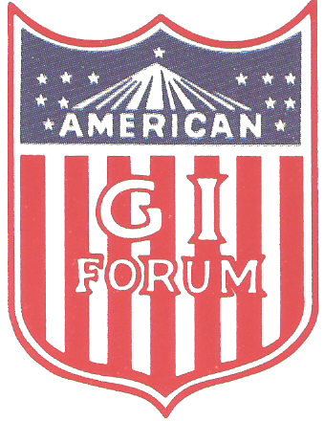

AMERICAN GI FORUM OF KANSAS EDUCATIONAL FUND
2021 SCHOLARSHIP APPLICATION
GENERAL INFORMATION AND INSTRUCTIONS

PURPOSE AND ELIGIBILITY

The purpose of the American GI Forum of Kansas Educational Fund scholarships is to assist Hispanic and other qualified students in completing their higher education. AGIF-Kansas Educational Fund scholarships are available on a competitive basis to undergraduate, vocational technical, and graduate students. Awards normally range from $200 to $1,000. Verification of school enrollment must be submitted within 1st six weeks of start of semester or you will not receive scholarship. All awards will be distributed in 2 (two) semesters. You or a member of your family must be present at the State Conference to accept the scholarship. Scholarship will not be awarded if not present. Selection criteria has been revised to give more credit to your continuous involvement in the American GI Forum and other volunteer community activities..

APPLICATION DEADLINE

Postmark by April 16, 2021, insures acceptance. Regular mail is preferred and there is no need for certified or other special mailings that delay the review process. If a receipt is desired, send a self-addressed stamped envelope.

SELECTION

The AGIF-Kansas Educational Fund scholarship program evaluates applicants on the following priority order and criteria:
1. Academic Achievement 4. Two (2) letter of recommendation
2. Personal Statement 5. Membership in GI Forum of Kansas
3. Financial Need Analysis (send copy of membership card)
6. Wallet size photo

*** IMPORTANT INSTRUCTIONS ***

It is the applicant’s responsibility to see that all materials are complete and sent on time. THE TOTAL APPLICATION PACKAGE IS TO BE SENT TOGETHER AND IN THE ORDER NOTED BELOW AND POSTMARKED BY April 16, 2021, OR EARLIER.

- Application form (Typed)
- Personal statement – must include American GI Forum activities in which you have participated (Typed)
- Transcript (unofficial accepted, grade cards or grade reports NOT accepted.)
- Two (2) letters of recommendation (sealed accepted)
- Copy of 2021 membership card or chapter roster submitting membership.
- Application and ALL required documentation MUST be typed.

MAIL TO: Barbara Olivas Email: barbarao @pld.com
1000 North Cheyenne Phone: (620) 356-4070
Ulysses, Kansas 67880 Cell Phone: (620) 575-6138

